Temperature and Humidity Sensor Integration Overview
The temperature and humidity sensor was integrated into our cloud computing architecture, using the following simulated MyDevices.com sensors for the initial setup, with plans to deploy real sensors with ESP8266 microcontrollers in the final phase of the project.
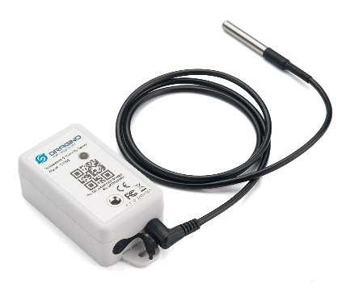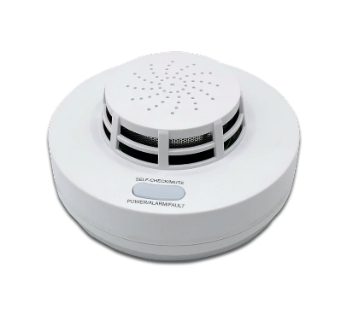
In the architecture, simulated temperature/humidity and smoke sensor data is transmitted using MQTT, a lightweight messaging protocol that facilitates efficient data communication between IoT devices and the cloud platform hosted on Node-RED.
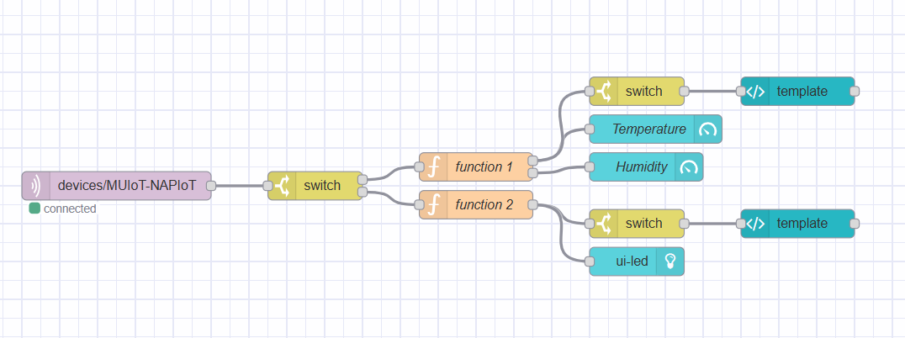
The MQTT node receives the signals from the two simulated sensors. Therefore, it must be separated through a Switch node that identifies the hardware id and separates the properties into two outputs. Each output then passes through a Function node that separates the received data. For the first function, it splits the temperature and humidity data. This data is presented through a Gauge node that is visualized in the dashboard. Finally, a Switch node is applied to identify when the temperature is greater than 20° (for example) an alarm and a stop button are lit that are programmed in http code.
The same logic is applied to Function node 2. In this case, the values returned are 1 if smoke is detected, and 0 if not. A Led node is added if the output is 1 it lights up red and if the output is 0 the Led lights up green. A Switch node is added to turn on an alarm set in template if smoke is detected.

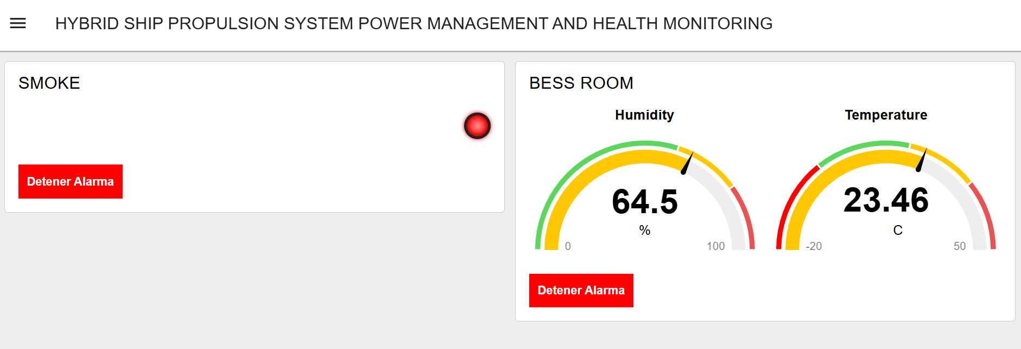

Once the system transitions from simulated to real environments using ESP8266, the setup will maintain the integrity of data transmission using MQTT to Node-RED, where data processing and decision-making processes occur. The ESP8266 will be responsible for reading sensor outputs, converting them into a format suitable for analysis, and publishing them to the designated MQTT topics. Node-RED, configured on FlowFuse, will then subscribe to these topics, process the incoming data, and dynamically update the dashboard to reflect real-time environmental conditions. This real-time visualization is crucial for immediate response to potential hazards and for long-term environmental monitoring, ensuring that data-driven insights are accessible through a user-friendly interface on the dashboard, enhancing operational efficiency and safety.

